**Weekly report**

*Work on transfer learning*

*Work on Generative Adversarial Networks (GANs)*

Elliot trained a network to generate Chinese handwriting-style images! (Contained in a .gif)

There are some tweaks we can still experiment with as we used the data for 100 unique outputs (whereas we have data for 4000 unique outputs) and we still haven’t merged the train and test tfrecords files.

Also we are currently updating the generator twice for everytime the discriminator is updated. The generator also has a learning rate of 10-3 while the discriminator has a learning rate of 10-4. The generator has high fluctuations in its loss, maybe its learning rate is too large.

We have been trying to find implementations of vector image addition, but no one seems to put any code on GitHub which we can build on. We may have to work directly from research papers (which is unlikely to go well). However now with our experience in TensorFlow we will not struggle too much with the coding side of things.

Visualisation

Elliot’s next step with visualisation was to show the maximum outputs from an activation layer, as shown below. The first layer outputs display how much each pixel in the input image contributes to that feature. This is not the case with the second layer features and thus I propose a method whereby the second layer features are displayed by how much each input pixel contributes.

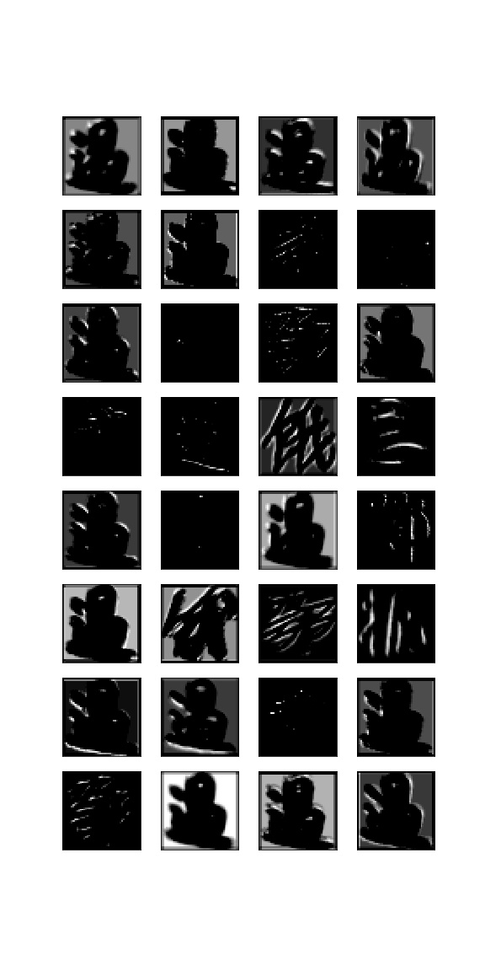

Figure 1: Activations from layer 1 shown for the character where they are maximal

Other

Segmented some more Chinese calligraphy (Baotu Spring poem), as shown below. We have a script to normalise it as well.

Figure 2: Pipeline for GAN calligraphy conversion

Process

Manually segmented calligraphy character

*Label*



Convert with GAN

Identify with CNN

Handwriting version of calligraphy character

Our hope for a pipeline is shown in Fig. 2. We would take a calligraphy character, add the ‘concept’ of handwriting to it, and make it handwriting-esque, after which point we decode it.

It was suggested to us at the presentation that calligraphy carved on stone is much more akin to handwriting than calligraphy on paper. It would be very useful to compare these two forms of calligraphy, and see if our network can handle one better than the other.

Presented to a group of PhD and PostDocs our findings so far, out experience with neural networks and we discussed our project and theirs and how we can use neural networks to achieve our aims.

**Action points for the next week**

1. Carry on working on visualising the feature maps of our neural network for 100 outputs .

2. train a network for 100 outputs and transfer learn to 3866 outputs

3. Figure out how to do ‘vector image addition’ using the GAN to turn calligraphy writing into handwriting-esque characters

4. Segment the entire Baotu Spring poem

5. Retrain the GAN using both train and test tfrecords and all 4000 unique characters, as well as a slightly lower learning rate